Regulated Settlement
# Source: AI Source: Provided by: [Data Path: Persons Table -> ID Column: 1, Name_En Column: Motasem Essam] -> From: [ChatGPT] on [1/21/2026]
Regulated settlement in mobile money refers to when financial authorities (usually the central bank) oversee, enforce, and monitor how mobile money providers settle funds between wallets, merchants, agents, and banks. It ensures the stability, legality, and security of all monetary flows in the mobile money ecosystem.

🧠 Simple Definition
# Source: AI Source: Provided by: [Data Path: Persons Table -> ID Column: 1, Name_En Column: Motasem Essam] -> From: [ChatGPT] on [1/21/2026]
Regulated settlement means that mobile money transactions are cleared and settled under the rules and supervision of a financial regulator — such as a central bank or national payment switch.

📋 Why It’s Important
# Source: AI Source: Provided by: [Data Path: Persons Table -> ID Column: 1, Name_En Column: Motasem Essam] -> From: [ChatGPT] on [1/21/2026]
- Prevents fraud, misuse, and money laundering (AML)
- Ensures settlement finality and traceability
- Enforces KYC (Know Your Customer) and record keeping
- Protects users and merchants from settlement delays or risks
- Supports interoperability across providers and banks

🏦 How Regulated Settlement Works
# Source: AI Source: Provided by: [Data Path: Persons Table -> ID Column: 1, Name_En Column: Motasem Essam] -> From: [ChatGPT] on [1/21/2026]
- Mobile money provider (e.g. Vodafone Cash) initiates settlement batches.
- Funds are moved between pooled accounts, commercial banks, or agent accounts.
- The central bank or national payment switch (e.g., Meeza in Egypt) verifies:
  - Transaction logs
  - Balances to be settled
  - KYC compliance
- Only then is the final settlement executed (ACH/RTGS/netting).
- Reports and audits are submitted regularly to the regulator.

🌍 Examples of Regulated Mobile Money Systems
# Source: AI Source: Provided by: [Data Path: Persons Table -> ID Column: 1, Name_En Column: Motasem Essam] -> From: [ChatGPT] on [1/21/2026]
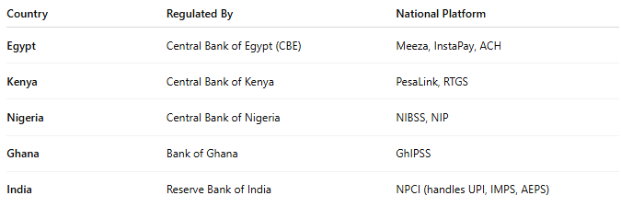

Country | Regulated By | National Platform
Egypt | Central Bank of Egypt (CBE) | Meeza, InstaPay, ACH
Kenya | Central Bank of Kenya | PesaLink, RTGS
Nigeria | Central Bank of Nigeria | NIBSS, NIP
Ghana | Bank of Ghana | GhIPSS
India | Reserve Bank of India | NPCI (handles UPI, IMPS, AEPS)

🛡️ Key Features of Regulated Settlement
# Source: AI Source: Provided by: [Data Path: Persons Table -> ID Column: 1, Name_En Column: Motasem Essam] -> From: [ChatGPT] on [1/21/2026]
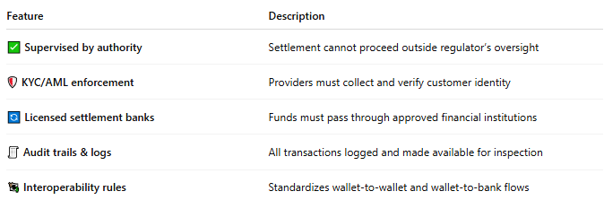

Feature | Description
✅ Supervised by authority | Settlement cannot proceed outside regulator’s oversight
🛡️ KYC/AML enforcement | Providers must collect and verify customer identity
🔄 Licensed settlement banks | Funds must pass through approved financial institutions
🧾 Audit trails & logs | All transactions logged and made available for inspection
💱 Interoperability rules | Standardizes wallet-to-wallet and wallet-to-bank flows

🔁 Example: Egypt (CBE & Meeza)
# Source: AI Source: Provided by: [Data Path: Persons Table -> ID Column: 1, Name_En Column: Motasem Essam] -> From: [ChatGPT] on [1/21/2026]
- All mobile money providers (Vodafone, Orange, Etisalat) must:
  - Use Meeza cards or wallets as settlement base
  - Settle to banks through ACH or CBE-approved systems
  - Submit daily transaction reports to CBE
  - Follow KYC + AML rules for wallet creation

✅ Benefits of Regulated Settlement
# Source: AI Source: Provided by: [Data Path: Persons Table -> ID Column: 1, Name_En Column: Motasem Essam] -> From: [ChatGPT] on [1/21/2026]
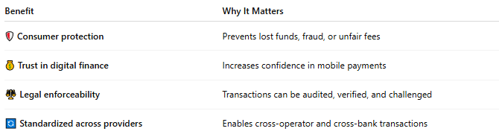

Benefit | Why It Matters
🛡️ Consumer protection | Prevents lost funds, fraud, or unfair fees
💰 Trust in digital finance | Increases confidence in mobile payments
⚖️ Legal enforceability | Transactions can be audited, verified, and challenged
🔄 Standardized across providers | Enables cross-operator and cross-bank transactions

⚠️ Challenges or Considerations
# Source: AI Source: Provided by: [Data Path: Persons Table -> ID Column: 1, Name_En Column: Motasem Essam] -> From: [ChatGPT] on [1/21/2026]
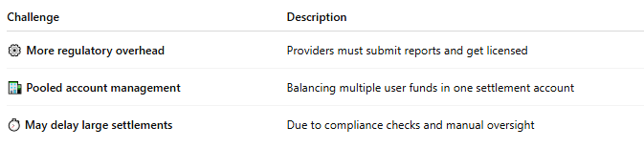

Challenge | Description
⚙️ More regulatory overhead | Providers must submit reports and get licensed
🏦 Pooled account management | Balancing multiple user funds in one settlement account
⏱️ May delay large settlements | Due to compliance checks and manual oversight

🧠 Summary
# Source: AI Source: Provided by: [Data Path: Persons Table -> ID Column: 1, Name_En Column: Motasem Essam] -> From: [ChatGPT] on [1/21/2026]
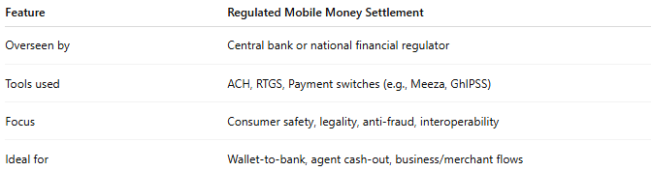

Feature | Regulated Mobile Money Settlement
Overseen by | Central bank or national financial regulator
Tools used | ACH, RTGS, Payment switches (e.g., Meeza, GhIPSS)
Focus | Consumer safety, legality, anti-fraud, interoperability
Ideal for | Wallet-to-bank, agent cash-out, business/merchant flows

